WEEK – 3 Assignments
Entity Framework Core 8. 0
Mandatory hands-on :-
Lab 1: Understanding ORM with a Retail Inventory System
Objectives :-
Understand what ORM is and how EF Core helps bridge the gap between C# objects and relational tables.
1. What is ORM?
ORM (Object-Relational Mapping) is a technique that lets you interact with a database using C# classes instead of writing SQL queries directly.
Benefits:
  - Productivity: Write less code and focus on business logic, not SQL.
  - Maintainability: Changes in your C# code are easier to manage than raw SQL scripts.
  - Abstraction: You don’t need to know SQL to work with the database.
2. EF Core vs EF Framework :
EF Core
- Cross-platform: Works on Windows, Linux, and macOS.
- Lightweight: Designed for performance and efficiency.
- Modern features: Supports LINQ, async/await, compiled queries, bulk operations, and JSON columns.
- Flexible: Works with many databases (SQL Server, SQLite, PostgreSQL, MySQL, and more).
- Actively developed: Receives frequent updates and new features.
- Best for: New projects, cloud apps, microservices, and cross-platform solutions.

EF Framework (EF6)
- Windows-only: Runs only on the .NET Framework.
- Heavier: More monolithic and less optimized for modern workloads.
- Fewer features: Limited async support, no compiled queries, fewer extensibility points.
- Less flexible: Mainly supports traditional SQL databases.
- Mature and stable: Well-tested and reliable for legacy applications.
- Visual designer: Includes EDMX for database modeling (not in EF Core).
- Best for: Maintaining existing Windows applications or when EDMX is required.

3. EF Core 8.0 Features:
- JSON column mapping: Store and query JSON data directly in SQL Server columns.
- Compiled models: Faster startup and query performance.
- Interceptors: Hook into database operations for logging or custom logic.
- Bulk operations: Improved support for inserting/updating many records at once.

4. Create a .NET Console App :
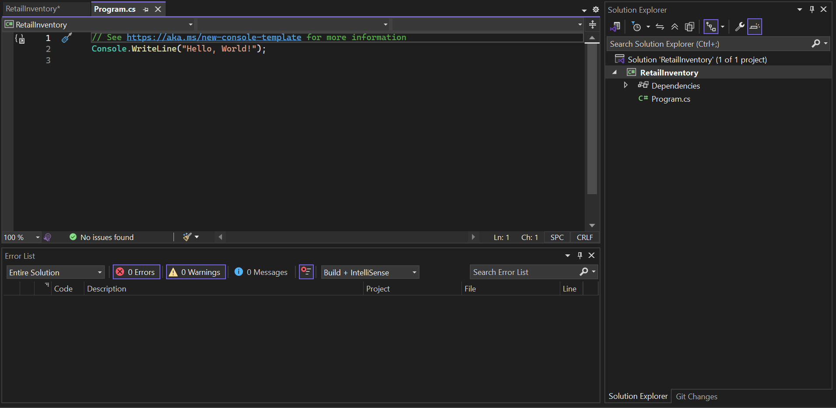

5. Install EF Core Packages:
- dotnet add package Microsoft.EntityFrameworkCore.SqlServer
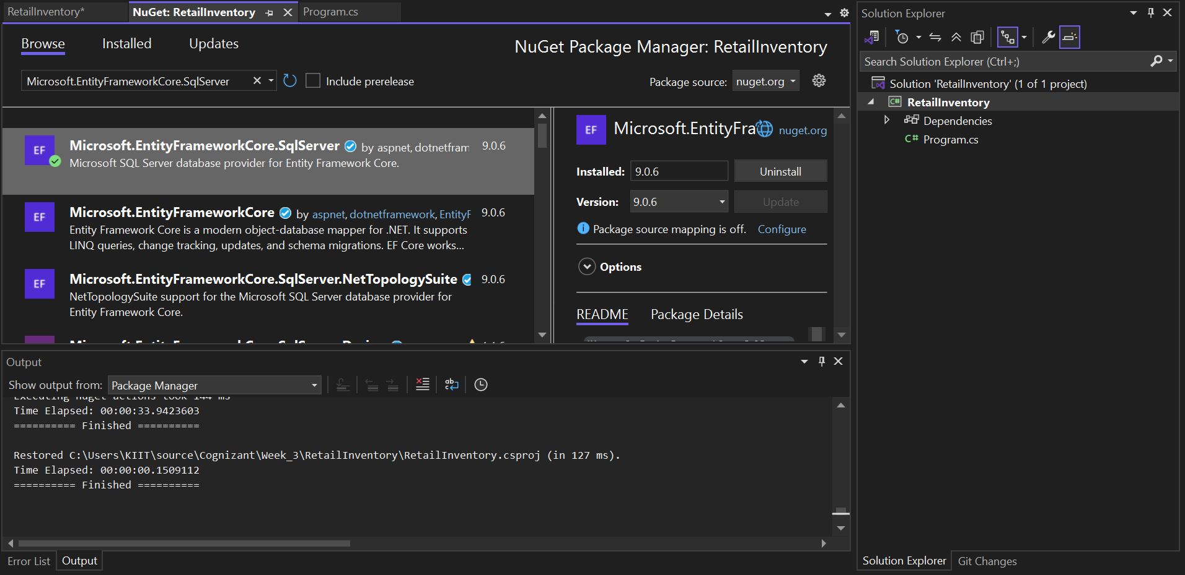
- dotnet add package Microsoft.EntityFrameworkCore.Design

